Why is it called a “Hot Dog”?
Listen to and read the following:
Name: | Date:
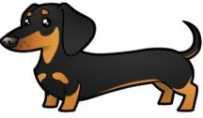
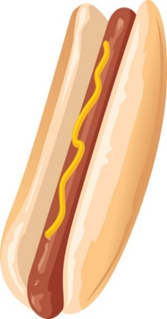
We all enjoy eating a hot dog now and then, but have you ever wondered why it was given such a strange name? Well back in 1900, a man earned money selling sausages on the streets of New York. He cooked them and then kept them hot in boiling water. His sausages weren’t selling well until he started to shout, ‘Get your hot dachshund sausages here!’ A dachshund is a long, thin, brown dog, which looks very much like a sausage. Amazingly, this caused a lot of interest and he sold a good number that day. A newspaper reporter was nearby and took a photograph of the sausage seller holding one of his sausages for a story in the paper. He did not know how to spell ‘dachshund’, so he named it a ‘hot dog’ instead. So, that’s how the name began. The salesman used to lend a pair of gloves to his customers to hold the hot sausages with, but then he found the solution. He thought of asking a baker to make him small long pieces of bread to put the hot dog in. It worked so well that it has continued to be sold the same way until today.

Circle T (True) or F (False).
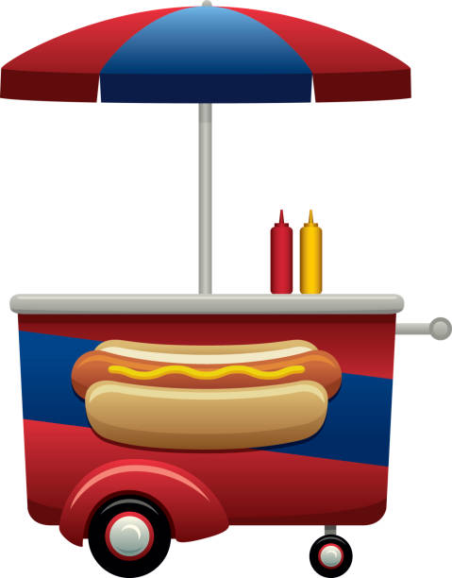
1 The first hot dog was made in 1900. T F
2 The hot dogs were sold raw. T F
3 The sausages were difficult to sell at first. T F
4 The sausages look like a dog. T F
5 At first the sausages were sold without bread. T F
6 A business man took a picture. T F
7 A reporter created the name “Hot Dog”. T F
8 A baker was asked to make big pieces of bread. T F
9 The hot dog has been successful for years. T F

