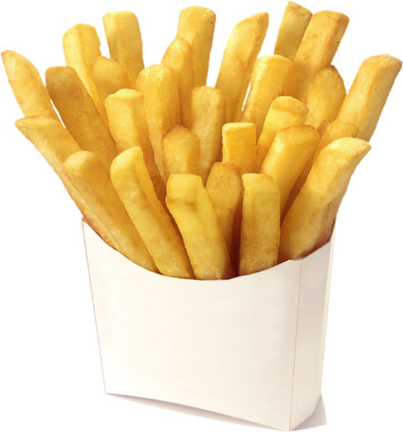

**Slow-Fried French Fries**

There are certain foods that are better when not made at home, like french fries. To achieve golden-brown perfection, you have to fry them twice: first at a low temperature, to poach them; then at a high heat, to crisp them up. Very tasty, very much a pain in the neck. A few years back, I read about how French chef Joel Robuchon supposedly does it at his house: He puts sliced potatoes in a pot of cold oil, turns on the heat, and lets them go. It sounds too simple to work. But as the temperature rises, the potatoes cook from the outer layer in until the fries are wonderfully crunchy outside and creamy in the center. You'll never make fries any other way-even if you've never made them before.

**Put a 🗶 in the right box:**

1. **The word *chef* (in line 6) means**

a person in charge of a hotel

a person who cooks

a person who waits on people

2. **In the text *fry* (line 3) means:**

to cook in a pan over heat with use of fat

to cut something into pieces

to slice something

8. **What does *a pain in the neck* mean?**

to have a problem with one’s neck

to please someone

to be annoying

7. **What does the word *crisp* mean:**

soft

crunchy

flexible

6. **The French chef J.R. has his**

own recipe

doesn’t know how to make French fries

doesn’t cook French fries at all

5. **French fries are better when cooked**

at home

in a restaurant

in a factory

4. **In the text *poach* (line 4) means:**

to cook in salty liquid

to cook in a boiling liquid

to fry

3. **The word twice (in line 3) means:**

one time

two times

three times